Name of the project: Find Your Fit
Name of the students:
- Jenny Rachel Jiji – 10 G
- M. Samiksha – 10 G
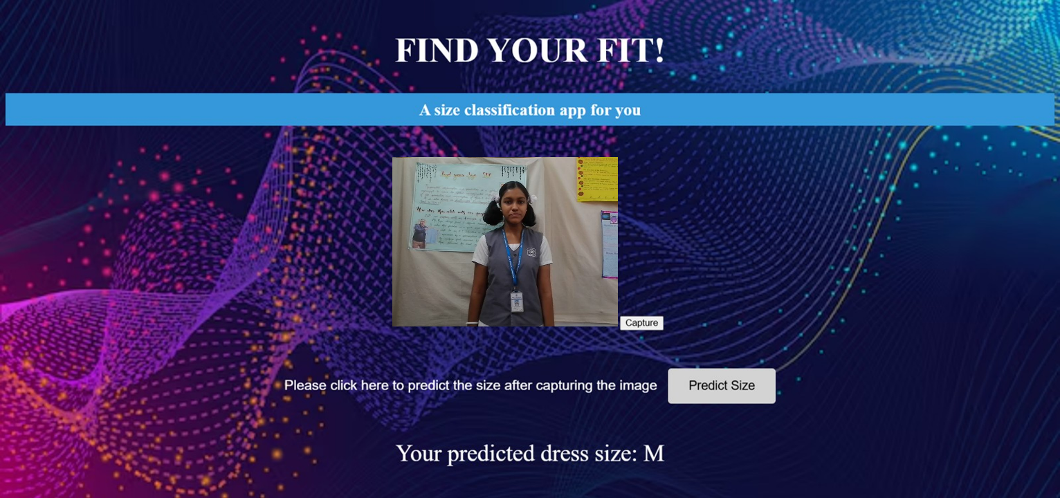
Explanation:
When people buy clothes online, in many cases, people do not get the required size of clothes as they are unable to find the accurate fit or measurements for them online. Hence customers are not satisfied and end up having to request for a replacement or an exchange. In line with SDG 12 (Responsible Consumption and Production), this AI model, Find Your Fit, classifies the size of a person (S, M or L) from their image captured from real-time camera. The processing in the model takes place in the following manner:
- The image is converted into grayscale and edges are detected from it.
- It is further converted into a binary pattern and is represented in a feature map using statistical and visualisation methods.
- These features are converted into a 1D array.
- The model predicts the size of the new image using Random Forest Classifier, by matching new data features with pre-defined threshold values.
- The final output is displayed through a HTML website integrated with the Python code through Flask.

